

**Savitribai Phule Pune University**

Interdisciplinary School of Scientific Computing

**Course No. :** SC – 101

**Title :** Programming Languages & Principles – I (Test- III)

#### Date: 25 Sept, 2018 Marks : 30

Time : 2:00pm to 3:30pm

**________________________________________________________________**

**Q1. Answer any six. (2 marks each.)**  (12)

1. For a simple undirected graph G with **n** vertices and **m** edges, state true or false for each of the following –
   * 1. m = n implies it is a tree
     2. ∑deg(V) = m
     3. m ≤n x (n-1) / 2
     4. If G is connected then m ≥ n-1
2. Draw recurrence tree for the following equation and write the depth of the tree –
   1. T(n) = T(n/2) + T(n/2) + log(n)
3. What form of recurrences can be solved using the Master Method?
4. Can Master Method be applied to solve the following recurrence equations? Please mention which case of the Master Method, if any is applicable and the solution.
   * 1. T(n) = 16T(n/4) + n
     2. T(n) = 3T(n/3) + n/2
5. Differentiate between Greedy method and Dynamic programming method of algorithm design.
6. When do we use Divide-and-Conquer method and when do we use the Dynamic programming method?
7. Please answer the following two questions.
   1. What is the asymptotic time complexity of BFS on a Graph G with V being its set of vertices and E its set of edges?
   2. What is the asymptotic time complexity of DFS on a Graph G with V being is set of vertices and E its set of edges?
8. Write the adjacency matrix for the graph given in Figure 1. 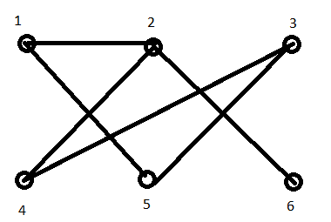

Figure1

**Q2. Answer any two. ( 5 marks each.)** (10)

1. Write the BFS (Breadth First Search) algorithm for an undirected Graph and answer the following questions based on your algorithm.
   1. For the graph given in Figure 1, if the source vertex is given to be vertex 5, what would be the order in which the vertices will be visited?
   2. Which vertex would be farthest from the source vertex and what would be the distance of it from the source?
2. Write the recursive DFS (Depth First Search) algorithm for an undirected Graph and answer the following questions based on your algorithm.
   1. For the graph given in Figure 1, if the source vertex is given to be vertex 3, what would be the order in which the vertices will be visited?
   2. Which vertex would be farthest from the source vertex and what would be the distance of it from the source?
3. Write the iterative DFS (Depth First Search) algorithm for an undirected Graph and answer the following questions based on your algorithm.
   1. For the graph given in Figure 1, if the source vertex is given to be vertex 3, what would be the order in which the vertices will be visited?
   2. Which vertex would be farthest from the source vertex and what would be the distance of it from the source?

**Q3. Answer any one. ( 4 marks each.)**  (8)

1. Write the fastest line algorithm for the assembly line problem.
   1. Figure 2 shows the assembly line with the fastest line marked with thicker black line. However, some of the stations on line 1 have been upgraded recently and the times they take have changed. So using your algorithm, check the values of f* (fastest way through stations on the two lines) for all the stations.
   2. The fastest wayhighlighted by the thick line is “enter L1 S(1,1) S(2, 2) S(1, 3) S(2, 4) S(2,5) S(1,6) exit L1”. With the updated stations of line 1, what would be the fastest way now? You can draw on the figure OR write in the same fashion as above.

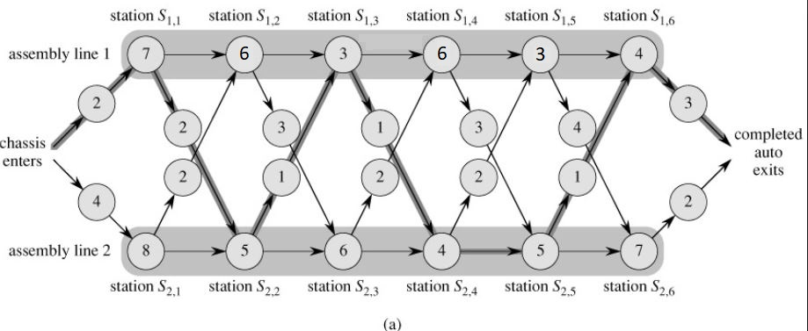

Figure 2

1. A Knapsack with the maximum capacity given in kgs needs to be filled with items selected from the given list of items. For each item its weigh in kgs and its cost price is given. It can be assumed that all of them can be sold for the same price. Write the algorithm to maximise the profit.
   * 1. Apply this algorithm to the following set of items and list the selected items in appropriate order. The capacity of the Knapsack is 30 kgs.
     2. What is the asymptotic complexity of this algorithm?
     3. Explain what would need to change in the algorithm if the values given under cost were actually profits and not the costs associated with the items.
     4. Based on the condition given in (c ) above, what items will be selected?

|  |  |  |  |  |  |  |  |  |  |  |
| --- | --- | --- | --- | --- | --- | --- | --- | --- | --- | --- |
| **Items No** | 1 | 2 | 3 | 4 | 5 | 6 | 7 | 8 | 9 | 10 |
| **Weight** | 8 | 8 | 12 | 20 | 5 | 2 | 15 | 6 | 14 | 10 |
| **Cost** | 13 | 17 | 12 | 45 | 3 | 5 | 5 | 6 | 6 | 10 |

**\*\*\*\*\***